[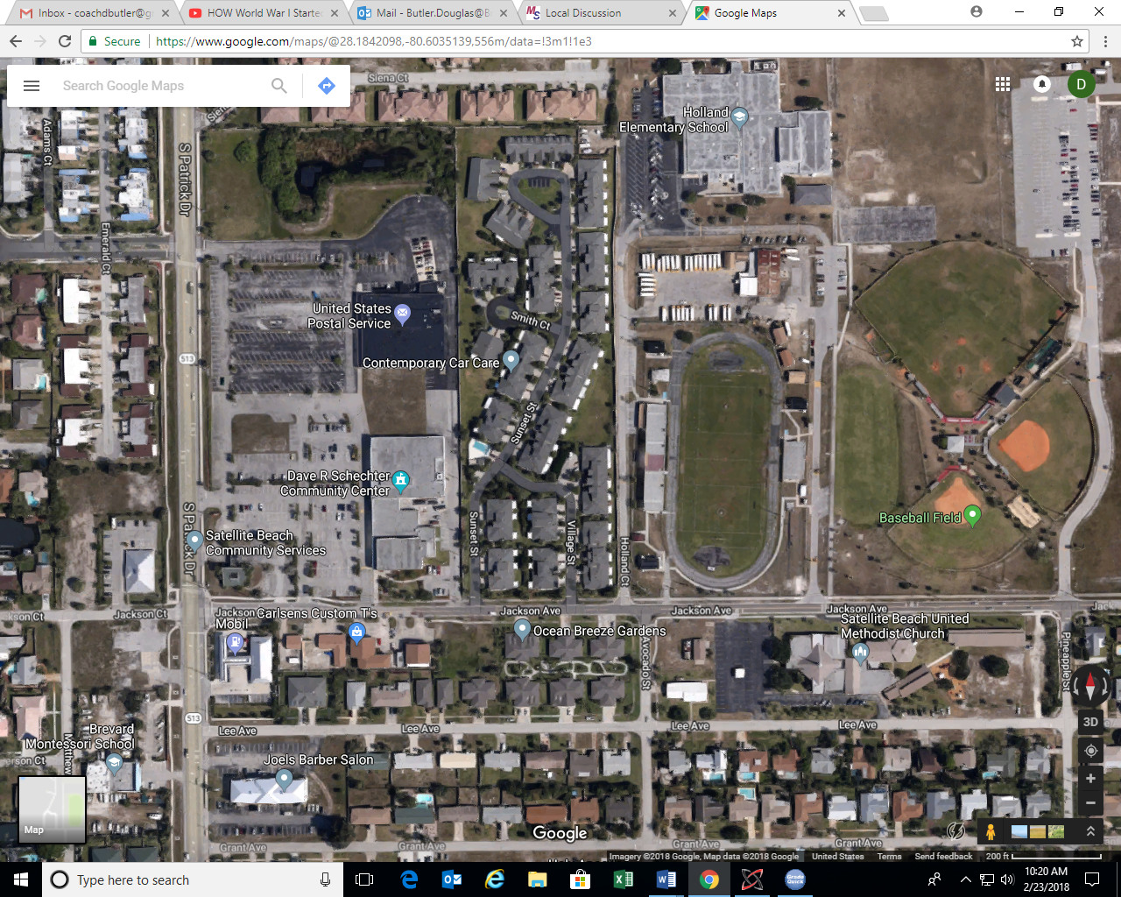](2018%20home%20meet%20map.docx)